Abertay Language Centre
EAP in the North

When: Friday, December 5th 2014, 2.00 – 4.30pm
Where: Abertay University, Dundee

The BALEAP TEAP CPD Scheme
“Facilitating the education, training and professional development of those involved in the teaching, research and scholarship of English for Academic Purposes (EAP) to enhance the student academic experience.”

Olwyn Alexander and Carole Macdiarmid

Abertay Language Centre, Abertay University, Dundee

EAP in the North,

December 2014

The BALEAP TEAP Portfolio Award and the EAP Teacher Competencies
“Facilitating the education, training and professional development of those involved in the teaching, research and scholarship of English for Academic Purposes (EAP) to enhance the student academic experience.”

TEAP Scheme Guide
http://www.baleap.org.uk/projects/teap-cpd-scheme

Olwyn Alexander and Carole MacDiarmid

Continuing Professional Development (CPD) & the BALEAP Teaching English for Academic Purposes Accreditation Scheme

Overview to the Framework & CPD

- The TEAP Scheme portfolio award guide provides an overview to the TEAP competency framework and the portfolio award scheme in particular.

- Essentially the competency framework can be used as a framework for EAP CPD; submission of a portfolio will also provide professional recognition and accreditation.

CPD: the relevance to our work as EAP professionals

The Competency Framework and Areas of Professional Practice Descriptors
E  Unit | Professional Development, Research and Scholarship | an EAP practitioner will:
E |  | recognize the importance of applying to their practice the standards expected of students and other academic staff whilst engaging individually and collaboratively in continuing professional development, research and scholarship in the TEAP discipline.
BALEAP (2014) Teaching English for Academic Purposes Continuing Professional Development Accreditation Scheme Handbook

Teachers engaging with/in research

...research engagement has the potential to be a powerful transformative force in the work and professional development of language teachers (Borg, 2010:391) .

Sample Job Description

To update and expand subject specific knowledge to further understanding of our field and related fields (including attending / presenting papers at professional meetings).

Getting started with the TEAP CF & the portfolio award scheme

Task 1: identification of role and familiarisation with units

- Look at the TEAP scheme pathways and role descriptors (see p. 5)

- Identify the role which you think most suites your current stage.

- Now consider the unit components and complete the preliminary ‘TEAP CF Self-assessment grid’(see over)

- How familiar/confident do you feel with each area (e.g. A/A1) ?

- What specifically could you do to develop areas you have identified?

  - Look specifically at the unit descriptors and indicative evidence (see p.14 onwards in handbook) )

N.B. whatever level /role you select, you might want to start with the Core Unit C (C1/2), common to all pathways

Task 2: planning your development activity

- Plan activities/tasks that you can do - it doesn’t need to be something ‘big’; you want to make your development programme manageable.

- Keep a log (see end for an example activity log )

- Start to collect examples of work to enable you to build up a portfolio.

Think about how to organise and store your work.

- organise files and folders on a flash drive &/or
- use an online resource such as Padlet (http://padlet.com/)

Building your portfolio: becoming a collector

Organising a folder & sub folders
- Name your docs for Unit (sub unit) and level
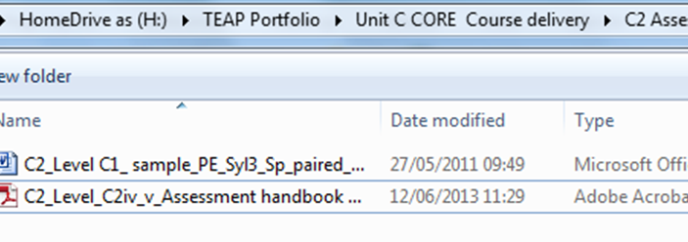
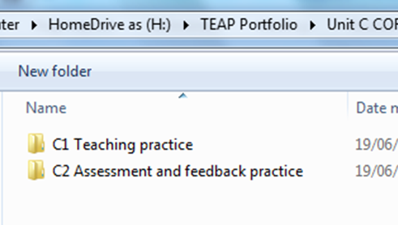
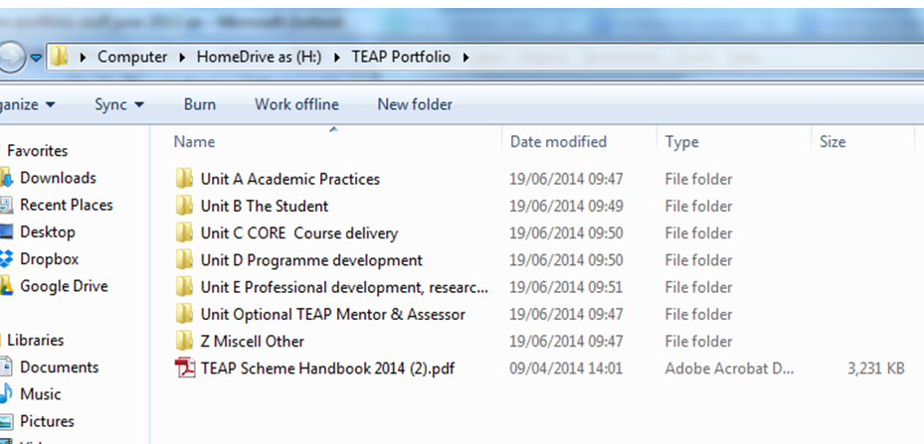

e.g. Sample Padlet page (http://padlet.com/)

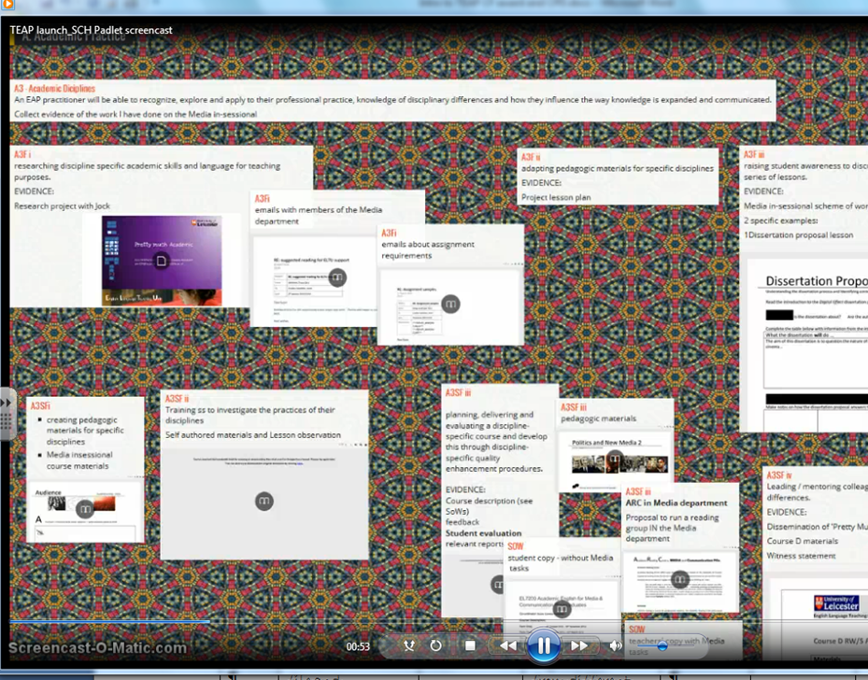
(Susie Cowley-Haselden; University of Leicester, 2014)
See also Susie’s Screen cast on using padlet and the RAPP –on LC EFL Unit CPD Moodle)

TEAP CF Self-assessment grid
 | Competency areas | How familiar/confident are you?  1=not very familiar  4= confident in this area |  | What specifically can you do?  a) think about action you can take during the course of the pre-sessional  b) identify specific examples of ‘evidence ‘ that you can collect /tasks you might complete
A Units | Academic Practices | an EAP practitioner will: | 1 2 3 4
A1 | Academic contexts | have sufficient knowledge of the organizational, educational and communicative policies, practices, values and conventions of tertiary education to operate successfully in such academic environments. |  | e.g. Task: Undergraduate vs Postgraduate: differing needs in EAP? Resource
A2 | Academic discourse | have a high level of systemic language knowledge including knowledge of genre and discourse analysis and use this to inform practice.
A3 | Academic disciplines | be able to recognize, explore and apply to their professional practice, knowledge of disciplinary differences and how they influence the way knowledge is expanded and communicated.
B  Units | The Student | an EAP practitioner will:
B1 | Student Needs | understand and apply knowledge of students’ prior learning experiences, their expectations, their personal, linguistic and academic needs and the academic literacy requirements of their target academic situation.
B2 | Student Learning | understand the relevance of individual differences to practice and the role and importance of critical thinking and autonomy in academic contexts and will employ tasks, processes and interactions that enable students to develop these.
C  Core  Units | Course Delivery | an EAP practitioner will:
C1 | Teaching practice | be familiar with the approach, methods and techniques of communicative language teaching, be able to locate these within an academic context and apply these to the design and planning of learning activities and to teaching the language and skills required by academic tasks and processes. |  | b) e.g. lesson planning for specific groups; keep LP; self-reflection, TP FB sheet
C2 | Assessment and feedback practice | be able assess academic language and skills competence using appropriate formative and summative assessment and provide appropriate feedback.

TEAP CF Self-assessment grid
 | Compete-ncy areas | How familiar/confident are you?  1=not very familiar  4= confident in this area |  | What specifically can you do?  a) think about action you can take during the course of the pre-sessional  b) identify specific examples of ‘evidence ‘ that you can collect /tasks you might complete
D  Units | Programme Development | an EAP practitioner will:
D1 | Course design | understand the main types of language syllabus and will be able to deliver and transform a syllabus into a course or programme that addresses students’ needs in the academic context within which the EAP provision is located.
D2 | Quality Assurance & Enhancement | be able to use, design and implement a range of quality assurance and enhancement instruments and utilize results to inform development of own teaching practice, course quality and the student academic experience.
E  Unit | Professional Development, Research and Scholarship | an EAP practitioner will:
E |  | recognize the importance of applying to their practice the standards expected of students and other academic staff whilst engaging individually and collaboratively in continuing professional development, research and scholarship in the TEAP discipline.
Optional  Unit | TEAP  Mentor & Assessor | A TEAP Mentor will be able to guide others in their continuing professional development, evaluate competencies and verify portfolio evidence.  A TEAP Assessor will be able to evaluate EAP training & development provision for BALEAP award accreditation purposes and assess portfolio-based evidence for BALEAP practitioner accreditation purposes.
Table adapted from
BALEAP (2014) Teaching English for Academic Purposes Continuing Professional Development Accreditation Scheme Handbook
Example CPD log
Date/Course | What I plan to do (& TEAP competence area) | Why | TEAP Unit  (A-A1 etc) | Evidence collected /stored  (for unit/sub unit/level; x-ref to indicative evidence) ) | What I learnt from this | How I can use it/further action  (TEAP Unit  (A-A1 etc)) | Notes
e.g.  Summer PS, 2014/ Block B | Researching & planning an academic reading skills lesson (for specific group and sub-skills) | Investigate text processing in detail | C1_ g__vi & vii | Lesson plan, self-reflection and observer FB | See self-reflection | (note action points)
Summer PS, 2014/Block C | Compare reading text from the Law file and engineering file- (Block B)  (A1 Disciplinary differences) | Familiarize myself with texts from different genres | A1 | (sample lessons for future reference) | etc | Etc  Develop lesson plan for X (A1F, i);  Write up comparative analysis- e.g. discourse features (A2, d; A3)

Notes

